Academic Program Review Self-Study Template
Instructions: This template is provided as a resource for drafting your APR Self-study. The final draft of your self-study must be entered into Watermark’s Planning & Self-study (P&SS). The information entered for each element can be copied and pasted into the corresponding section in P&SS.
Please note that if you decide to use this as a Google Doc, some of the fields' functionality will be lost.
Before using this template, a copy should be saved as a Word doc.
- Open the template in Word.
- From the File menu, select “Save As” then “Browse.”
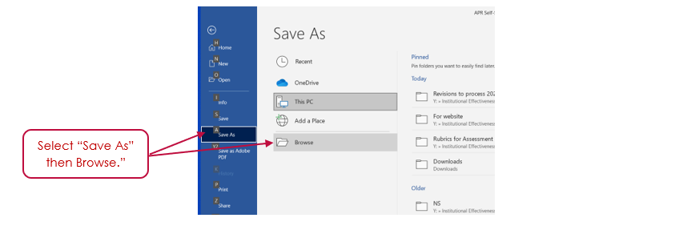
- Navigate to where you want to save the file. Under “Save as type” select “Word Document.” Change the name of the file and then click on “Save.”
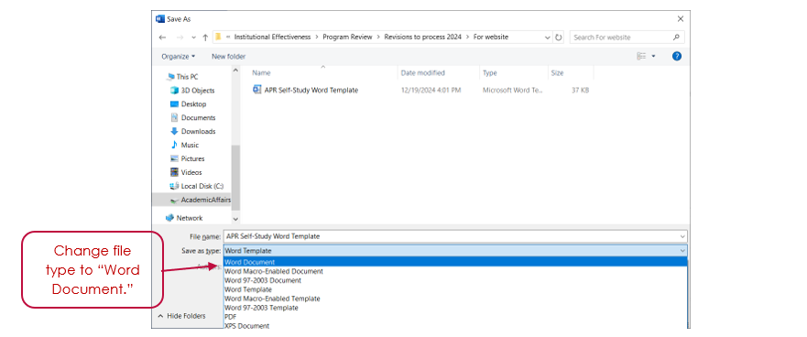
- The template is now ready to be completed. Click on the Bold Blue to enter information.

Academic Program Review Self-Study Template
Program: Enter program title.
Year of Review: Select year from dropdown.
- Program Overview (no more than 2 pages)
- Introduction
Provide a brief description of the program. Include the following information:
- Degree(s) offered
- History of the program
- Context of where it’s housed within the University (what department, etc.)
- How the program supports the University’s mission and strategic plan
Enter introduction.
- Mission Statement
Enter the program’s mission statement. Discuss any changes to the mission statement since the last review.
Question(s) to consider:
- Have there been any changes to the mission? If yes, what was the rationale for those changes?
- Is the mission statement current and relevant? Does it need to be updated?
Resource(s):
- Checklist for reviewing a mission statement (Appendix F)
Enter mission statement.
- Changes since last APR (If this is your program’s first APR, leave this section blank.)
- Provide a summary of the recommendations from the program’s last APR, the changes that were made in response to those recommendations, and the impact of those changes.
- Discuss any other changes that have occurred since the last APR, including the rationale for and impact of those changes. Changes discussed should focus on actions intended to impact the program as opposed to an individual course within the program.
Resource(s):
- Action items from assessment of student learning (annual assessment reports)

Enter changes since last APR.
- Peer Programs
Provide a list of three to five peer programs. These may or may not be programs within the University’s peer institutions. You should identify peer programs that are most like your program and/or are aspirational programs.
Resource(s):
- Identifying peer programs (Appendix D)

List peer programs.
- Program Details (no more than 3 pages)
- Enrollment
Discuss the trends in the program’s student enrollment and how they compare to that of its peer programs.
Question(s) to consider:
  - Is student enrollment and credit hour production adequate and/or appropriate to support the program and create an environment of continued success for students?
  - How does the program’s enrollment compare to that of its peer programs? (If data is available.)
Resource(s):
- Student Enrollment by Semester for the Last Five Years
- Student Credit Hours generated by program majors

Enter discussion on enrollment.
- Curriculum
Describe the course pathway students take to complete this degree program.
Question(s) to consider:
    - How does the design of the curriculum facilitate student learning?
    - Does the curriculum reflect coherence in sequencing and increasing complexity?
    - What changes, if any, have been made to this pathway or degree requirements over the course of this cycle? What was the rationale for these changes?
    - How does the program’s curriculum compare to that of its peer programs, including the inclusion or exclusion of program requirements?
Resource(s):
- Degree plan
- Curriculum Map
- Guide to creating a curriculum map (appendix G)

Enter discussion on curriculum.
- Program Learning Outcomes
Enter the program’s student learning outcomes. Discuss the relevance of these outcomes and how they are addressed through the curriculum.
Question(s)s to consider:
- How do these outcomes pertain to the program’s mission?
- Do the learning outcomes reflect the knowledge, skills, and values students will need to successfully pursue a career in their chosen profession and/or continued studies?
- How do the student learning outcomes align with industry needs?
- What changes, if any, have been made to these outcomes? What was the rationale for these changes?
- Do all of the key courses address at least one outcome? Are the outcomes addressed in a logical order?
- Are all outcomes first introduced and then reinforced?
- Do students get practice on all the outcomes before being assessed, e.g., in the capstone?
- Do all students, regardless of which electives they choose, experience a coherent progression and coverage of all outcomes?
Resource(s):
- Curriculum Map
- Guide to creating a curriculum map (Appendix G)
- Assessment of student learning (annual assessment reports)

Enter discussion on learning outcomes.
- Assessment of Program Learning Outcomes
Discuss the strategies employed to assess how well students achieve the program’s learning outcomes.
Question(s) to consider?
- What measures have been selected or developed to assess student learning outcomes? Is there at least one direct measure for each learning outcome?
- Do these measures provide adequate diagnostic information that allow faculty to identify students’ strengths and areas where additional support is needed?
- What changes, if any, have been made to the assessment process? What was the rationale for these changes?
- How do program faculty participate in the assessment process?
- What additional assessment opportunities are there that could be included in the assessment process?
Resource(s):
- Curriculum Map
- Guide to creating a curriculum map (appendix G)
- Assessment of student learning (annual assessment reports)

Enter discussion on assessment of learning outcomes.
- Student Outcomes Assessment (no more than 3 pages)
- Quality of Student Learning
Discuss the quality of student learning.
Question(s) to consider:
- To what extent have students met the program’s learning outcomes?
- Are there student learning outcomes where students perform particularly poorly or particularly well?
- Is the standard for achievement set at an appropriate level?
- Are there student learning outcomes where the standard for achievement should be raised or lowered?
- Is the standard understood and agreed upon by all faculty?
- Where data are available, how do the program’s students compare to students in other USA programs or nationally?
Resource(s):
- Assessment of student learning (annual assessment reports)

Enter discussion on quality of student learning.
- Student Progression through Program
Discuss students’ ability to progress through the program and graduate.
Question(s) to consider:
- Has student retention remained in an acceptable range?
- Are completion rates in line with expectations?
(GR Programs: Is time to completion in line with expectations?)
- How does the program’s student retention and completion rates compare to that of its peer programs? (if data is available.)
- Do students exhibit difficulty progressing through the major at any point? If no, what are the things that faculty do that support student progression? If yes, at what points and/or why?
- Do students exhibit difficulty completing the program? If no, what are the things that faculty do that support student completion? If yes, at what points and/or why?
Resource(s):
- Retention and Graduation Rates (Undergraduate programs only)
- Time to degree (Graduate programs only)
- Course Success Rates
- Number of degrees awarded
- Assessment of student learning (annual assessment reports)

Enter discussion on students’ progression through the program.
- Quality of Instruction
Discuss the quality of instruction overall as well as in the program’s key courses.
Questions to consider:
- If there are areas of student learning identified as needing improvement (improving outcomes or raising standards), is modification/improvement of instruction identified as a possible means to improvement?
- Have there been efforts made to support and/or improve the quality of faculty instruction? If yes, what were those efforts?
- Did program faculty implement any high impact practices and what was their effect, if any, on student learning outcomes, faculty or student engagement, etc. (UG programs only)
Resource(s):
- Assessment of student learning (annual assessment reports)
- Student Perceptions
- Student Participation in High Impact Practices (UG program only)

Enter discussion on quality of instruction.
- Preparedness of Graduates
Discuss how prepared students are to enter the workforce and/or continue their education.
Question(s) to consider:
- How do the program’s student learning outcomes translate to knowledge, skills, and/or values that make your students attractive to potential employers and/or graduate school?
- How prepared did current and former students indicate they were to enter the workforce and/or continue their education?
- If your program includes an internship, practicum or other practical experience, how prepared do site supervisors find students to be?
- How do employers perceive program graduates?
Resource(s):
- Assessment of student learning (annual assessment reports)
- Summary of Post-Graduate Outcomes
- Student Perceptions

Enter discussion on discussion on preparedness of graduates.
- Summary and Action Plan (no more than 3 pages)
- Conclusions
Provide a summary of the significant conclusions drawn from the program review process. Include:
- Program’s strengths
- Areas in need of improvement
Data/evidence must be used to justify the conclusions.

Enter summary of significant conclusions.
Sections B – E:
Identify four action items, two short-term and two long-term, designed to have a positive impact on student achievement and the assessment of it. The description of each action item should include:
- A statement as to why a particular action plan was selected.
- The specific action steps to be taken.
- Details on how the action item will be implemented and monitored.
- Details on how the impact of the action item will be assessed.
- Timeline for implementing the action plan.

- Short-term Action Item 1
Enter short-term action item 1.
- Short-term Action Item 2
Enter short-term action item 2.
- Long-term Action Item 1
Enter long-term action item 1.
- Long-term Action Item 2
Enter long-term action item 2.
- Response to External Review
Enter discussion on curriculum.

